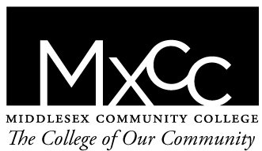
Middlesex Community College
Meriden Center
Bus Pass Application
Spring 2016

Middlesex Community College has a limited amount of bus passes available for active students living in the Meriden area who are experiencing difficulty securing transportation to our Middletown Campus. If you are interested in applying for a bus pass, please fill out this application.

Incomplete applications will not be accepted. Bus applications are awarded on a first come, first served basis. Applications will be accepted on a rolling basis. You must have completed the spring 2016 course registration process prior to submitting this application. Processing may take up to 7 business days.

Name:__________________________________________________________
Banner ID number:________________________________________________
Address:________________________________________________________
Phone:__________________________________________________________
Date:___________________________________________________________

- How many credit hours will you be taking in Middletown in the spring 2016 semester? _____
- Please explain the reason you are requesting a bus passes for the spring 2016 semester.__________________________________________________________________________________________________________________________________________________________________________________________________________________________________________________________________________________________________________________________________________________________________________________________________________________________________________________________________________________

Please submit your complete application to the Meriden Welcome Center Desk, Monday-Friday. 7:30am-3:00pm.

