
Differences Between Scholarly Journals and Popular Magazines

 | Scholarly | Popular
 | Charts, Formulas, Graphs  Serious appearance | Many graphics, Photos  Full-page advertisements  Bright, attractive covers
  Appearance
Advertising | Very little or highly specialized | Large amount
Audience | Specific (e.g., scholars, researchers, professionals, students) | General public.
Availability | By subscription only.  Paper and/or online | Sold at newsstands, supermarkets,  and the Internet
Author | Expert/specialist in field. Credentials usually given. | Not always identified. May be a staff writer or free-lancer.
Content | In-depth coverage of original research findings on narrowly-defined topics. | Broad coverage of a variety of current-interest topics.
Credits/Sources | Usually includes a bibliography and/or footnotes. | Few references may be included in the text.
Editors | Peer-reviewed by other  experts in the field. | Reviewed by editors  on staff.
Frequency of publication | Less frequently such as  monthly or quarterly. | More frequently such as  daily or weekly.
Language | Includes jargon of  the field (specialized vocabulary). | Non-technical and conversational  for any reader.
Readability | Advanced reading level | Basic reading level for a general audience
Length | Longer (usually >5 pages) | Shorter (usually <5 pages).
Publisher | Scholarly or professional organization, university press | Commercial, for profit
Purpose | To add to a body of knowledge and  inform the scholarly community. | To inform the public, entertain, sell a product, or promote a viewpoint.
Examples at the MxCC Library | College Mathematics Journal  Journal of Developmental Education  National Review  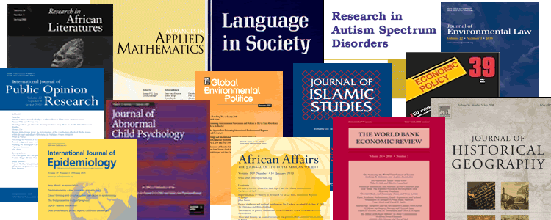 | Business Week, Health  Popular Science, Wired  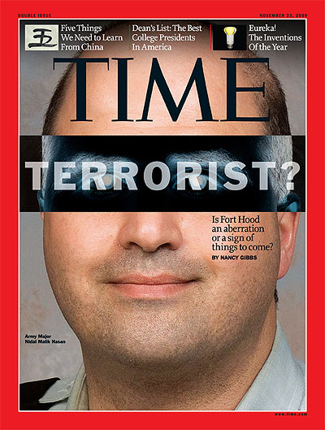

Tip: Many databases allow you to narrow or limit your search to ‘peer-reviewed or ‘refereed journals’, which will retrieve only scholarly journals matching your search terms.
Some points to remember:
- Both magazine and journal articles can be good sources for your work.
- When selecting articles, think about how you intend to use the information:
  - Do you want background on a topic new to you? (use magazines)
  - Did your teacher say to cite scholarly resources? (use journals)
- Sometimes a combination of the two will be appropriate for undergraduate research.
- When in doubt, check with your professor.

Finally, whatever sources you use, evaluate them carefully.
- Does the author show bias and does it affect his/her conclusions?
- Is the information accurate?
- Does the author support his/her arguments with credible evidence?

2017 MxCC Library

