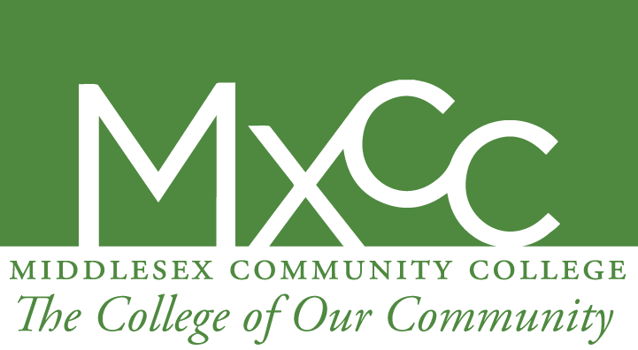

JOB SEARCH and CAREER ADVISING

Completing a course in the SNAP Employment and Training program is just one step toward pursuing a career. The information below can help you advance further in that journey.

Navigating the job market and preparing applications:

- Middlesex Community College Career Development services web site has information on creating a resume and cover letter and some employment search web sites. Includes information and tools on job search strategies and interviewing techniques.
http://mxcc.edu/cdcc/job-search-preparation/.

- The local Russell Library on Broad Street in Middletown has career services for resume writing, interview techniques, and career counseling. There is a job group every Thursday morning with guest speakers and networking, and special guest speakers at all times of the week, usually in evenings. Check out their web site :
https://www.russelllibrary.org/news_events/business_progs.html.

- I am available for limited guidance on cover letters, resumes, and job applications . I can also help you navigate the MxCC system to speak with others about taking further courses here. Contact me at pbarrett@mxcc.edu.

- In the following searches, be sure to specify the kind of job and location you are looking for. More employment search resources:

• Indeed
Search job sites, newspapers, associations and company career pages in one place.
• Simply Hired
Search millions of jobs across the web.
• Monster
One of the most popular job sites.
• CareerBuilder
Another well-known employment site.
Snag A Job

• CT Job Central
Connecticut's new job bank.
• CTJobs
Specifically targeted for local jobs.
• ConnecticutJobs.com
Another source for local jobs.
• State of CT Jobs
Find opportunities and examination dates.
• Idealist
Great career resources for resumes, interview guidance.
• Connecticut Department of Labor
Find local offices, including CTWorks and Career Centers.
• LinkedIn
Social networking for professionals.
• Workplace Writers
Tips for résumés and cover letters.

Good luck with your future endeavors and persist in all that you want !

